AI ASSISTANT CODING
NAME : G.Harshavardhan
HALLTICKET.NO :2403A52313
BATCH.NO :01
YR AND SEM :2ND AND 3RD

TASK DESCRIPTION 1:
QUESTION:
Try 3 different prompts to generate a factorial func on
PROMPT1:
generate a code in python factorial func on CODE WITH OUTPUT:
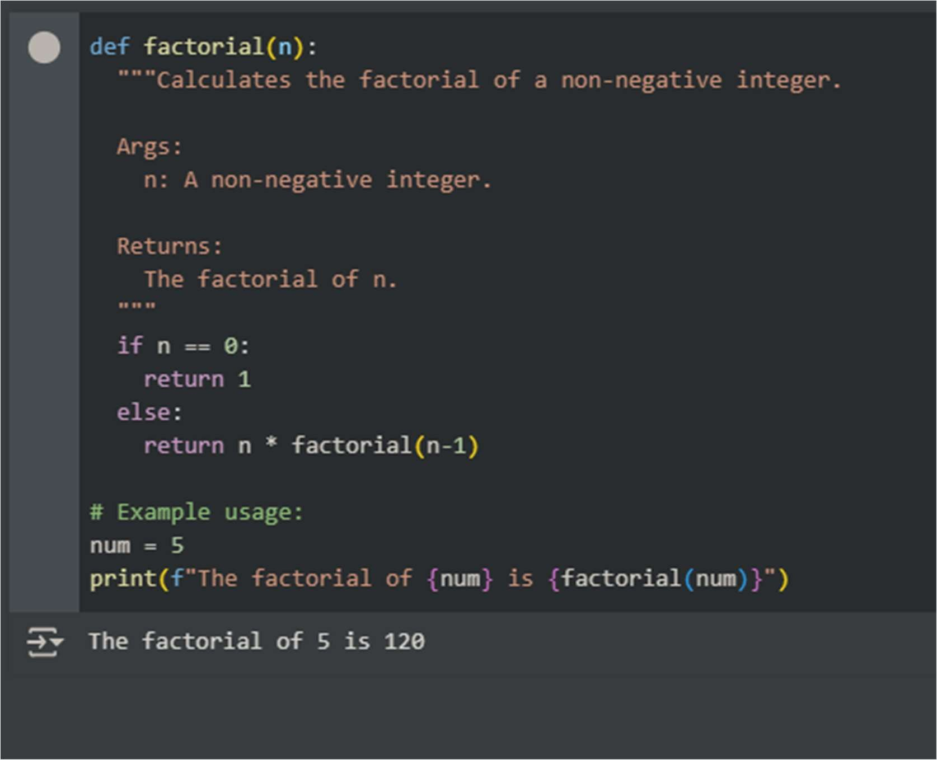
PROMPT2:
Write an efficient code for factorial func on
CODE WITH OUTPUT:

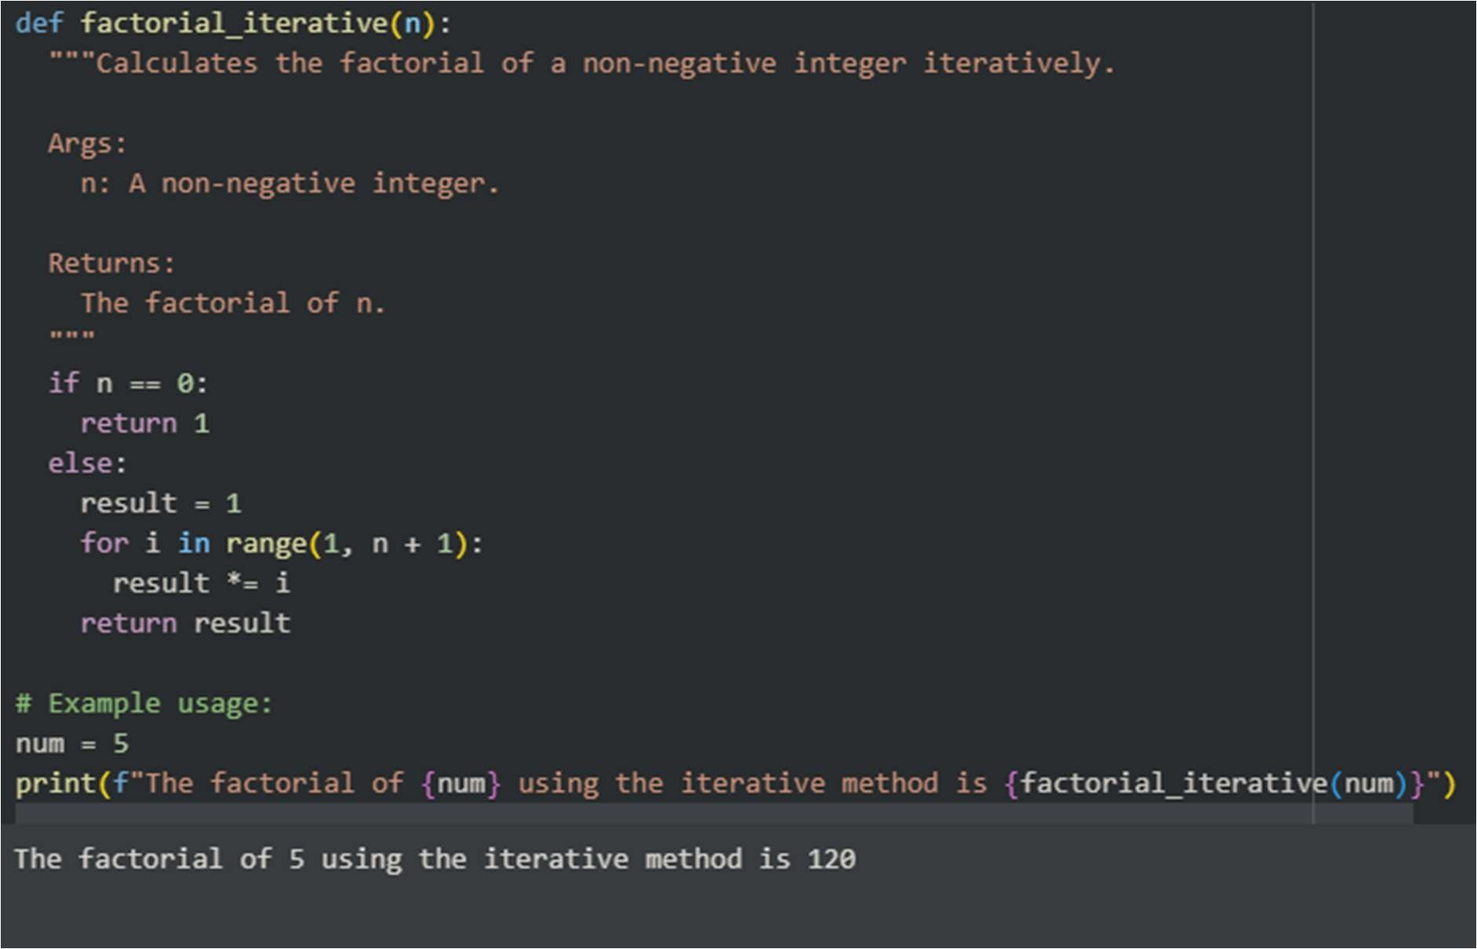
PROMPT3:
write a code on factorial in different approach with O(N) CODE WITH OUTPUT:
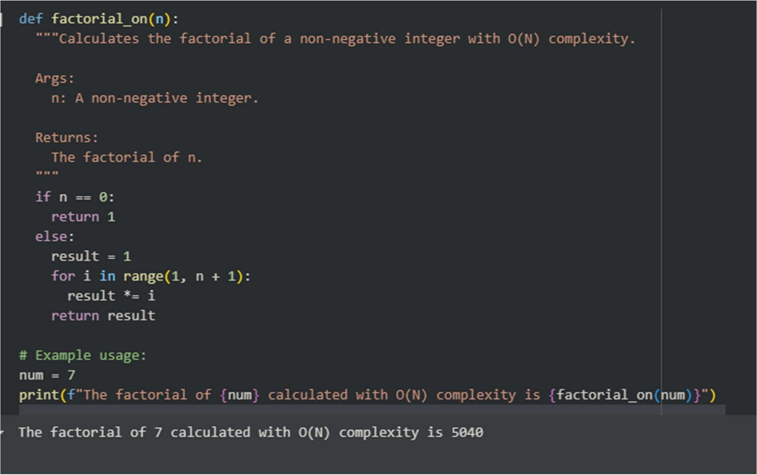

EXPECTED OUTPUT:
Comparison of AI-generated code styles
OBSERVATION:
All three valid implementa ons of the factorial func on produced the correct results for the examples we tested. However, the itera ve approach is generally preferred in prac ce for its efficiency and avoidance of poten al stack overflow issues with large inputs. The itera ve versions are essen ally the same in terms of their core logic and O(N) me complexity.

TASK DESCRIPTION 2:
QUESTION:
Provide a clear example input-output prompt to generate a sor ng func on
PROMPT: generate a code for sor ng in func on where input and output is given clearly
EXPECTED OUTPUT:
Func onal sor ng code from AI CODE WITH OUTPUT:
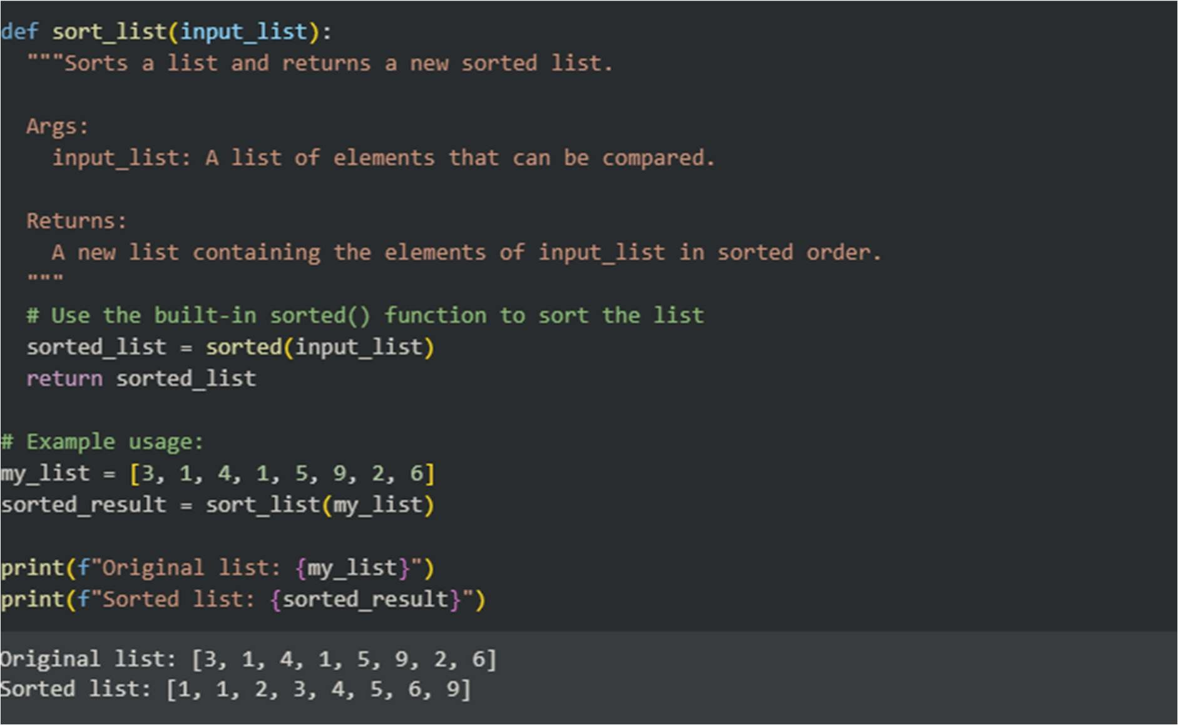
OBSERVATION:
The code defines a func on called sort_list that takes a list of items (like numbers in our example) and sorts them from smallest to largest. It uses a built-in Python tool called sorted() to do this easily. The important thing is that it gives you a new list that is sorted, leaving the original list unchanged.

TASK DESCRIPTION 3:
QUESTION:
Start with the vague prompt “Generate python code to calculate power bill” and improve it step-by-step
PROMPT:
Generate python code to calculate power bill by define power rates, get power consump on, calculate bill, display bill and finish the task.
EXPECTED OUTPUT:
Enhanced AI output with clearer prompts CODE WITH OUTPUT:
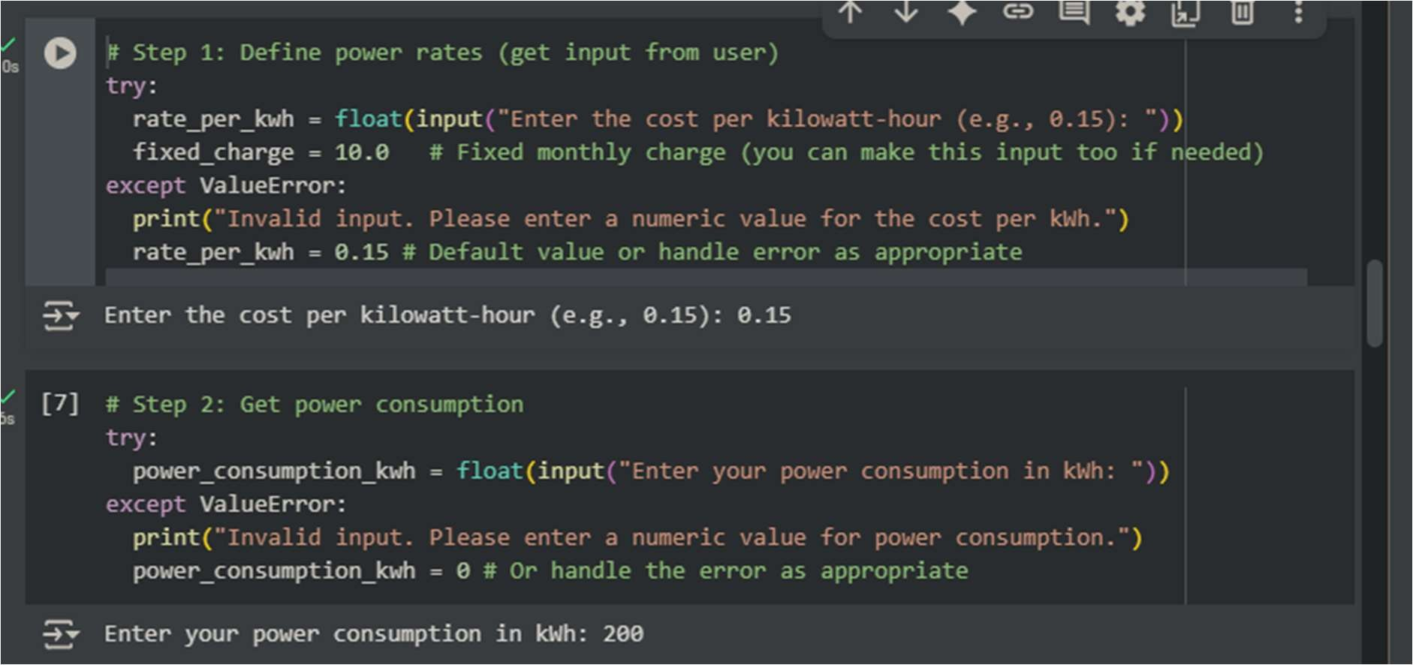
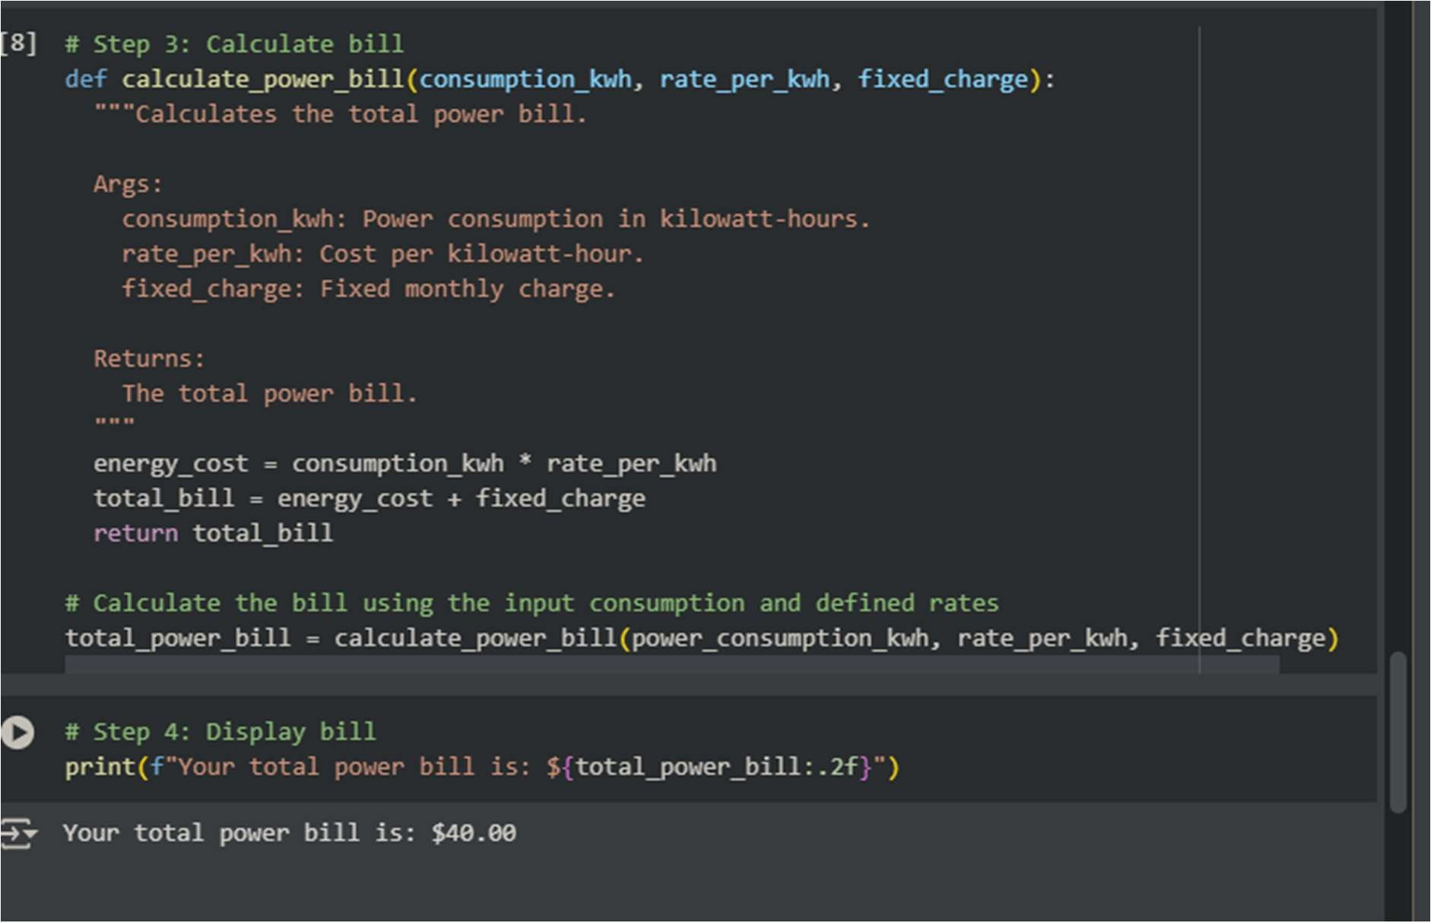
OBSERVATION:
Based on the power consump on I entered (200 kWh) and the example rates we used ($0.15 per kWh plus a $$0.15 per kWh plus a $10.00 fixed charge), the code correctly calculated and showed that the total power bill is $40.00. This means the energy cost was $$40.00. This means the energy cost was $30.00 (200 * $0.15) plus the $$0.15) plus the $10.00 fixed charge.

TASK DESCRIPTION 4:
QUESTION:
Write structured comments to help AI generate two linked func ons (e.g., login_user() and register_user()).
PROMPT:
# Func on: register_user # Goal: Register a new user in the system. # Inputs: # - username: The desired username (string). # - password: The user's password (string). # - email: The user's email address (string). # Outputs: # - Success message if registra on is successful (string). # - Error message if registra on fails (e.g., username already exists) (string). # Steps: # 1. Check if the username already exists in the database. # 2. If username exists, return an error message. # 3. If username does not exist, securely hash the password. # 4. Store the username, hashed password, and email in the database. # 5. Return a success message. # Linked Func on: This func on is linked to login_user(). A user needs to register before they can log in.
EXPECTED OUTPUT:
Consistent func ons with shared logic CODE WITH OUTPUT:
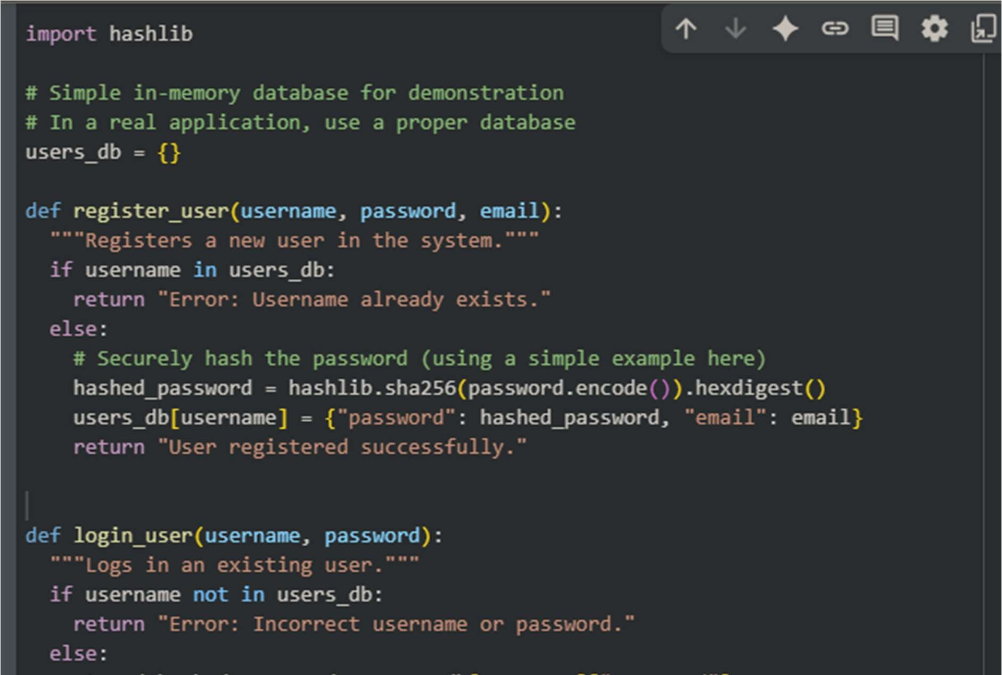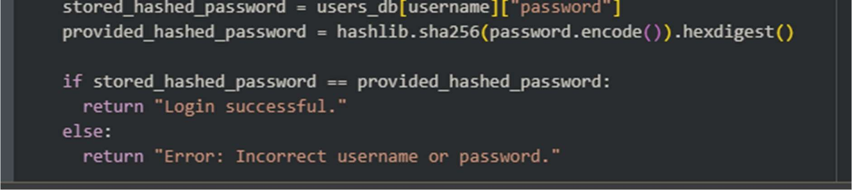
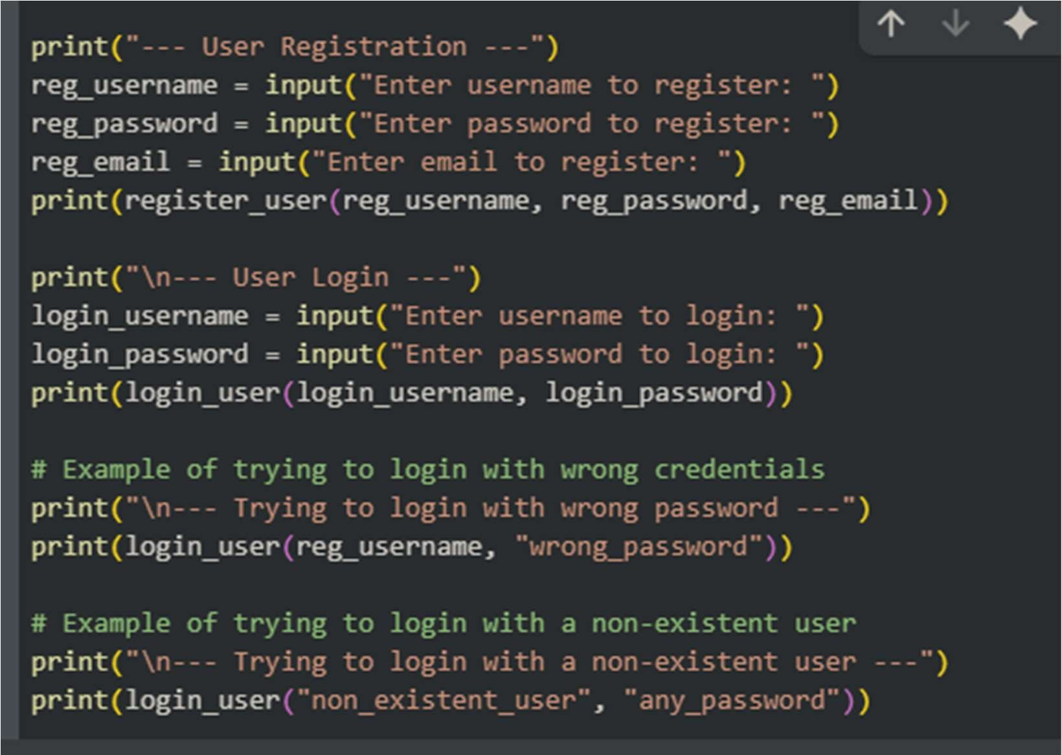
OBSERVATION:
The main observa on is that the code correctly dis nguishes between valid and invalid login a empts.
- When you provide the correct username and password that you registered, the code outputs a "Login successful" message.
- When you provide an incorrect password for a registered user, or try to log in with a username that doesn't exist, the code correctly outputs an "Error: Incorrect username or password" message.

TASK DESCRIPTION 5:
QUESTION:
Analyzing Prompt Specificity: Improving Temperature Conversion Func on with
Clear Instruc ons
PROMPT1:
Generate a code Temperature Conversion Func on with Clear Instruc ons with user’s input and output.
EXPECTED OUTPUT:
Code quality difference analysis for various prompts CODE WITH OUTPUT:
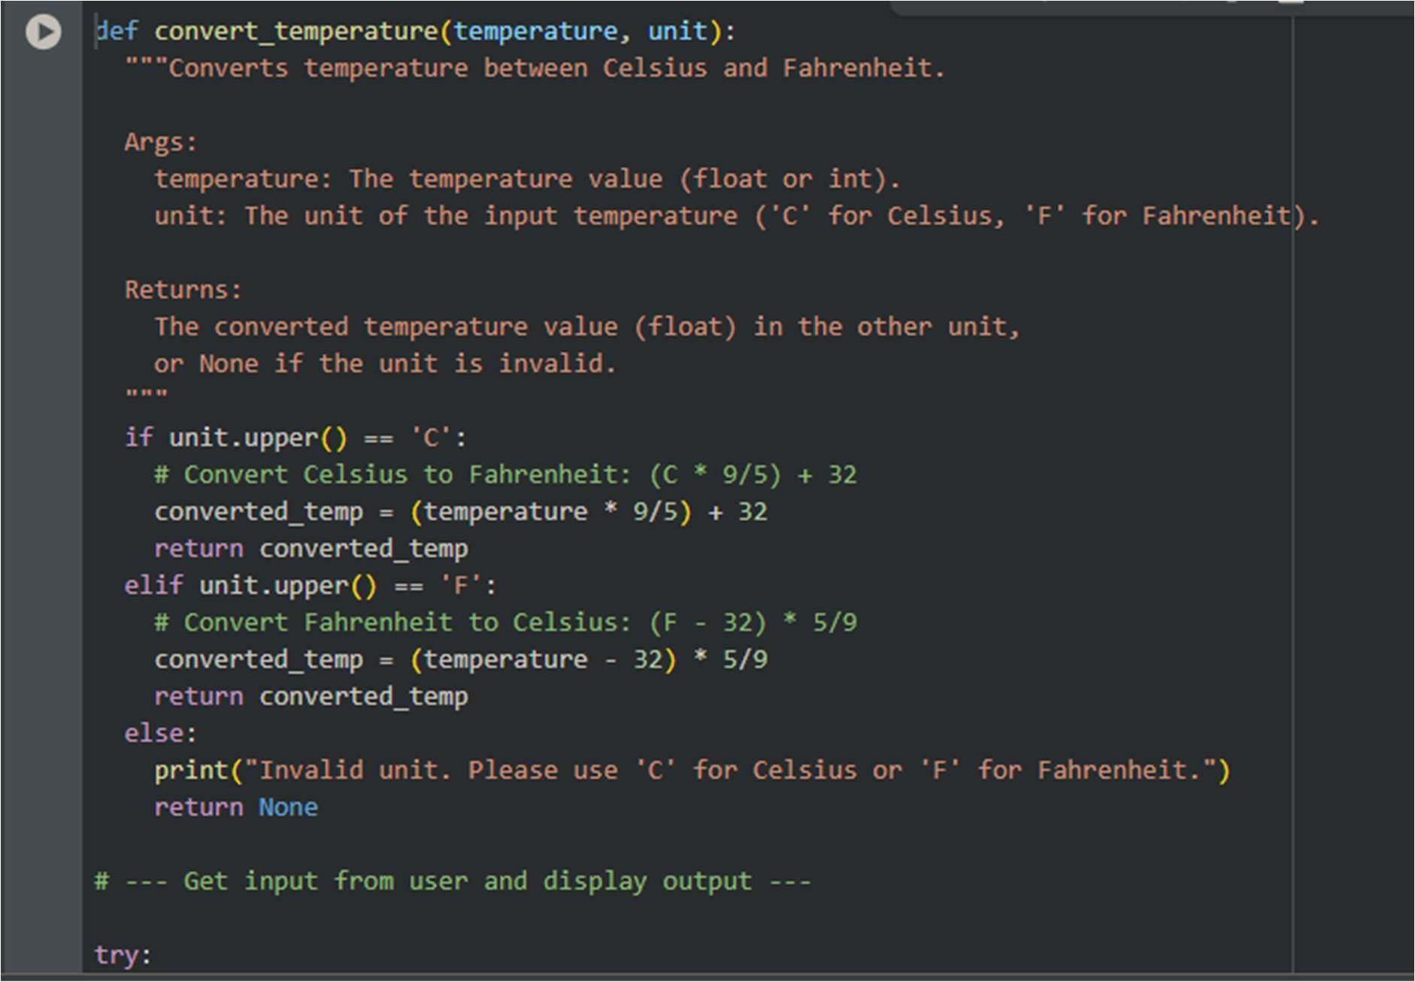
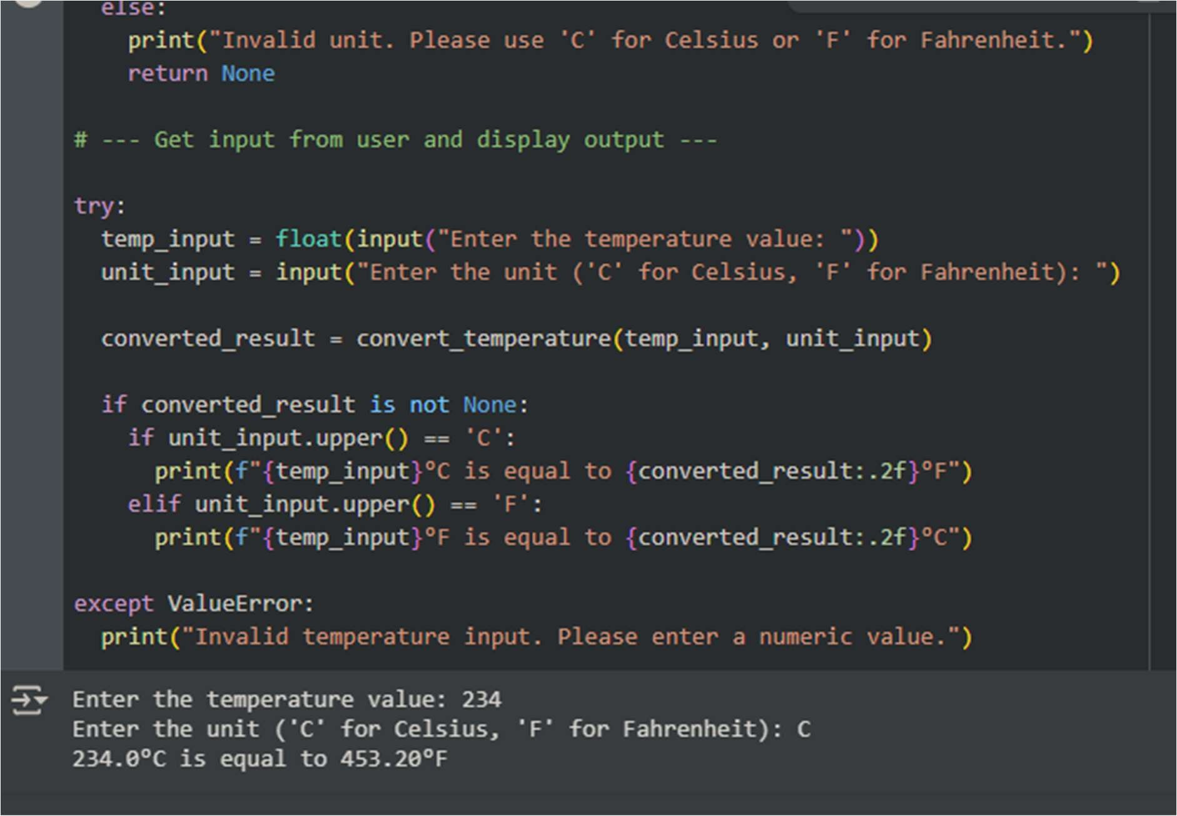
PROMPT 2:
Generate a code Temperature Conversion Func on with kelvin,celsiun,fahrenheit.

CODE WITH OUTPUT:
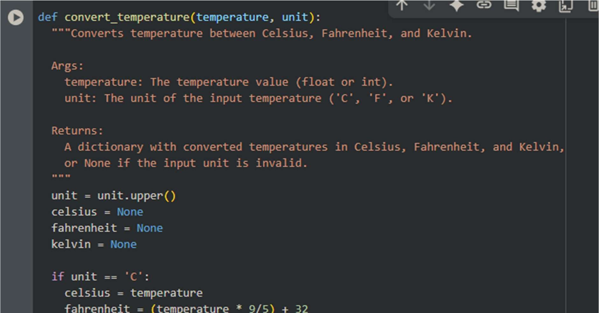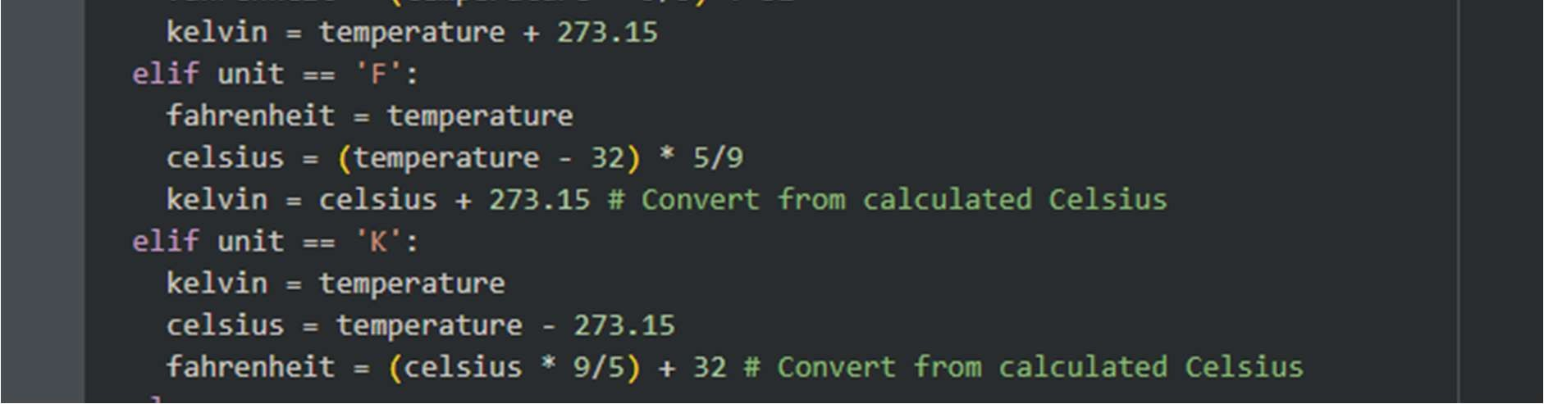

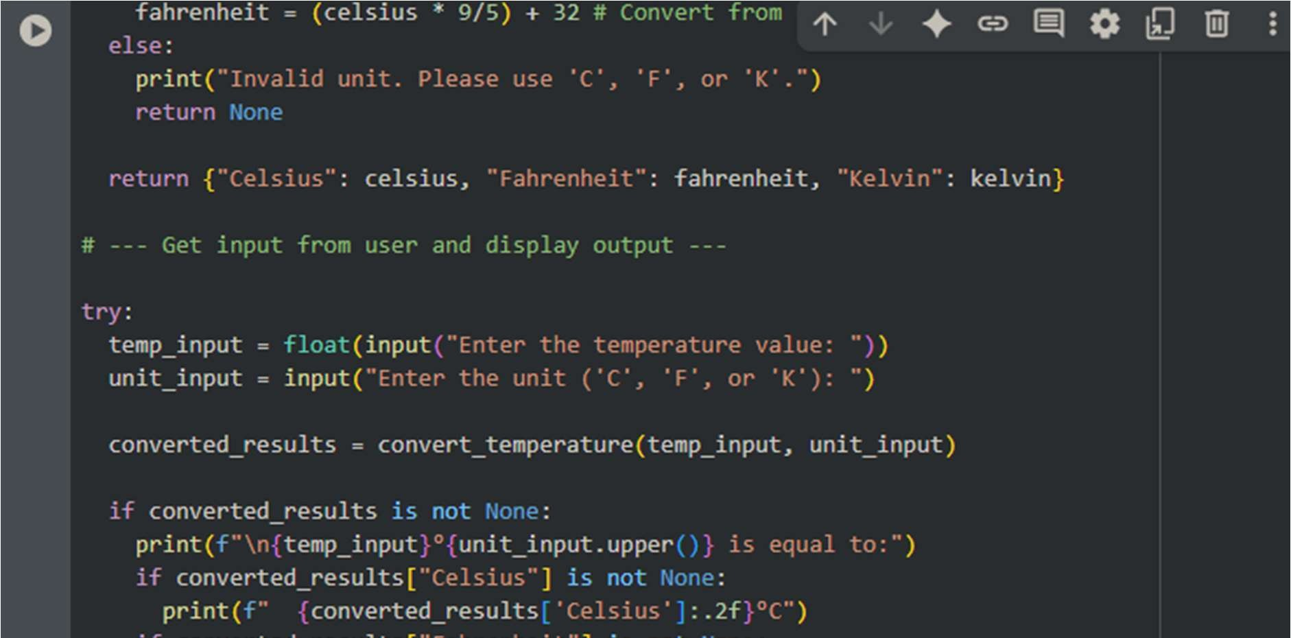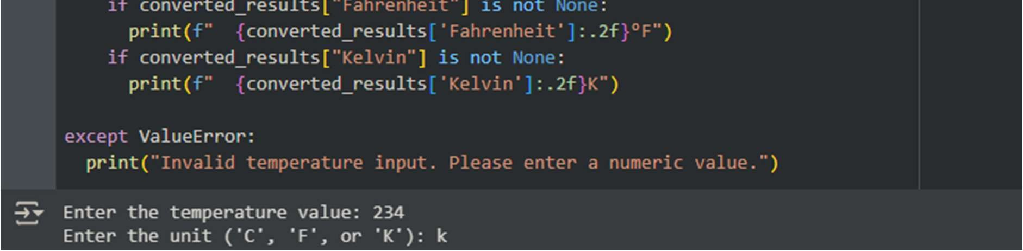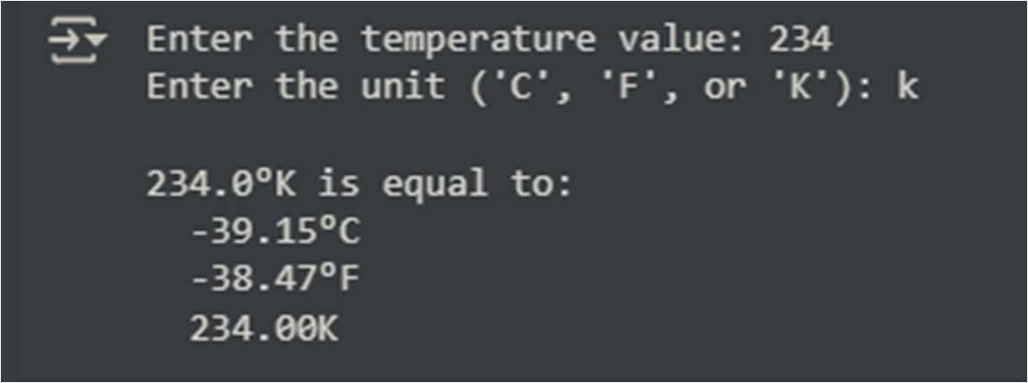

OBSERVATION:
The key difference is the scope of conversion and the output format. The first version did a single conversion and returned one value, while the second version does mul ple conversions and returns a dic onary of results, providing a more complete view of the temperature across different scales. The second version is more versa le as it includes Kelvin, which is important in scien fic contexts.

